Phase 2 · Develop
Exercise 6: Insights with the Claude API
Dev cycle | Develop (AI integration)
CC features | anthropic Python SDK, ANTHROPIC_API_KEY via .env, the build loop on an AI call, prompt engineering, structured JSON output
Time | 45 min
You produce | app/insights.py and a /reports/insights endpoint that summarises spending using Claude

Objective
The outside-world integration in this build is an AI call. You will direct Claude Code to wire the Anthropic Python SDK into ExpenseFlow so the API can return a natural-language insight over stored expenses. Treat the model exactly like any other dependency: key in .env, a typed function, graceful failure, and prompt iteration until the output is reliable. This is the heart of AI-assisted development: using Claude Code to build a feature that itself calls Claude.
Walk-through
1 | Install the SDK and store the key
Add the official Anthropic SDK to the venv and put your key in .env. The install is identical on both platforms because the venv is already active.
Run in terminal
PS> pip install anthropic
Create / paste → .env
ANTHROPIC_API_KEY=sk-ant-your-real-key-here
Never commit .env. If Claude has not already done so, ask it to add .env to .gitignore. Your key is a secret, like any password.
VALIDATE pip show anthropic prints a version. .env exists and is listed in .gitignore. The key is your real key from the Anthropic Console, not the placeholder.

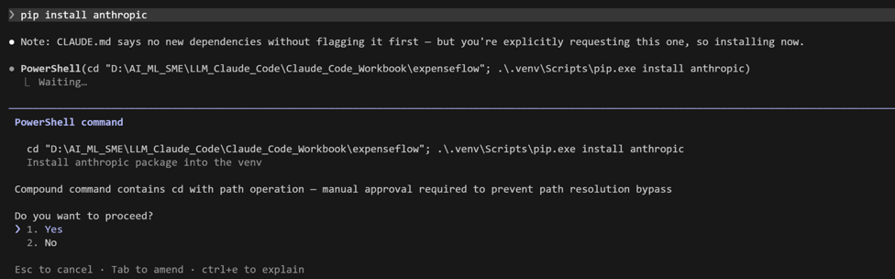

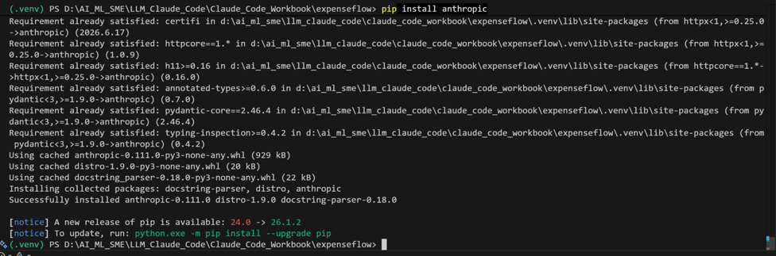
2 | Have Claude Code build the insights module
Drive the build loop: prompt, read the diff, approve, run. You are asking for a single typed function that calls the Messages API and fails safely.
Type this prompt into Claude Code
Create app/insights.py. Add generate_insight(expenses: list[dict]) -> str that calls the Anthropic Messages API using the anthropic SDK with model claude-sonnet-4-6. Load ANTHROPIC_API_KEY from the environment using python-dotenv. Build a compact text summary of the expenses (amount_base_minor, category, status) and ask the model for three short bullet insights about the spending. Set a small max_tokens. Wrap the call in try/except: on any API or network error, log it and return a safe fallback string. Add type hints and a module docstring.

VALIDATE Read the diff before approving: you should see client = anthropic.Anthropic(), a client.messages.create(...) call with model="claude-sonnet-4-6" and a max_tokens value, load_dotenv() near the top, and a try/except that returns a fallback. No key is hard-coded.
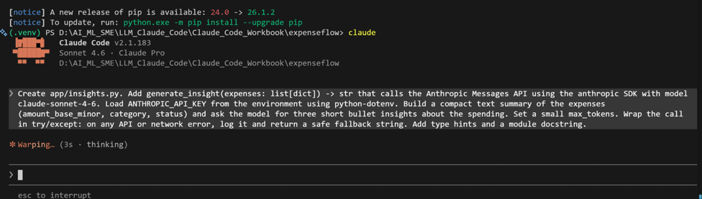

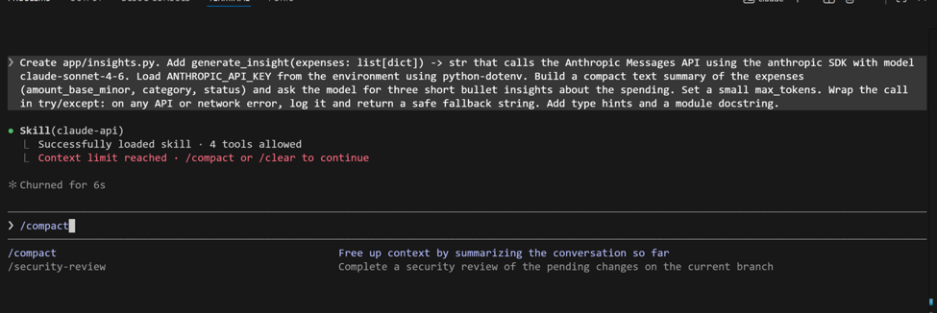
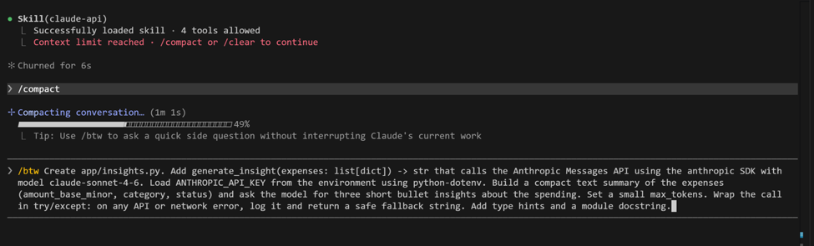
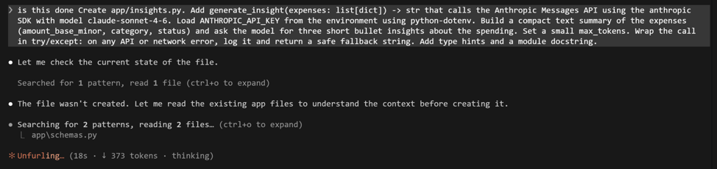

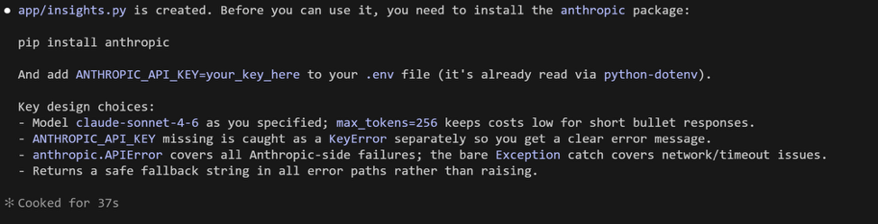

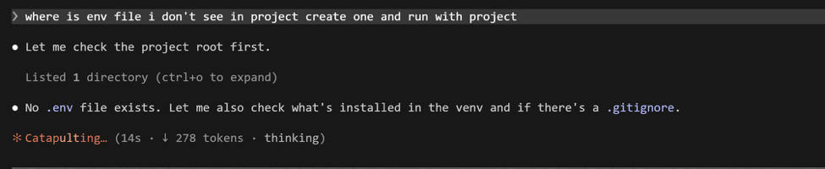
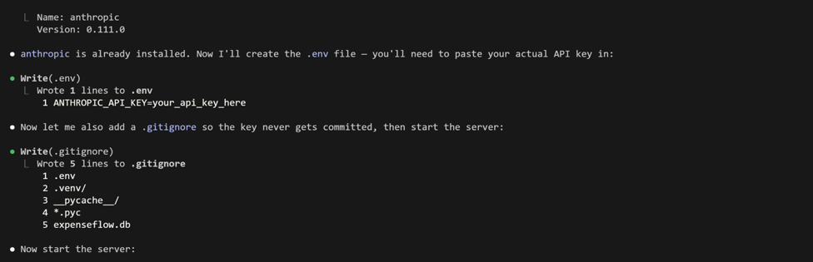

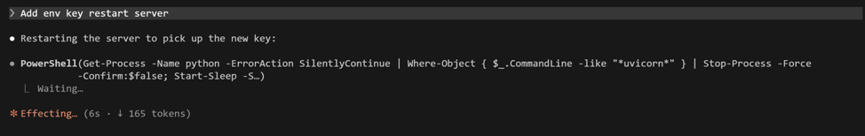

3 | Expose it as an endpoint
Point Claude at the files it must change with @ references so it edits the right route module rather than guessing.
Type this prompt into Claude Code
Add GET /reports/insights to app/routes.py. Load all expenses through the existing get_db dependency, convert them to a list of dicts, call generate_insight from app/insights.py, and return {"insight": ...}. Reference @app/insights.py and @app/routes.py so you edit the existing code.
VALIDATE The diff adds one route to app/routes.py and imports generate_insight. No duplicate router or app object is created.
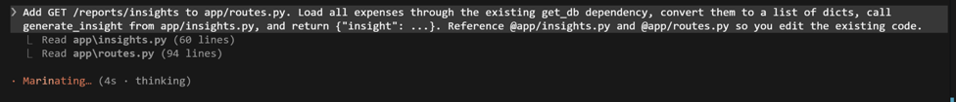
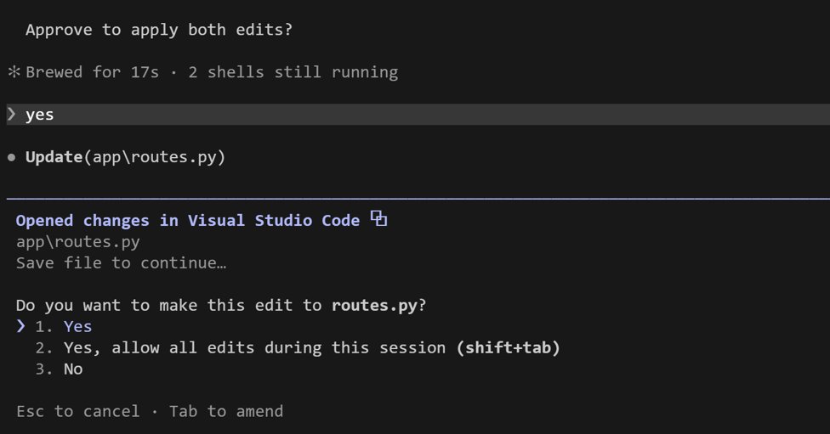
4 | Run the whole chain
Start the server and exercise the new endpoint from the live Swagger docs. Seed an expense or two first if your table is empty, or the model has nothing to summarise.
Run in terminal
PS> python -m uvicorn app.main:app --reload
Open in your browser (same URL on every OS)
PS> http://127.0.0.1:8000/docs
VALIDATE Calling GET /reports/insights returns three bullet insights that actually reflect the categories and amounts in your data. If you get the fallback string, check the uvicorn console for the logged error (usually a missing or wrong key).
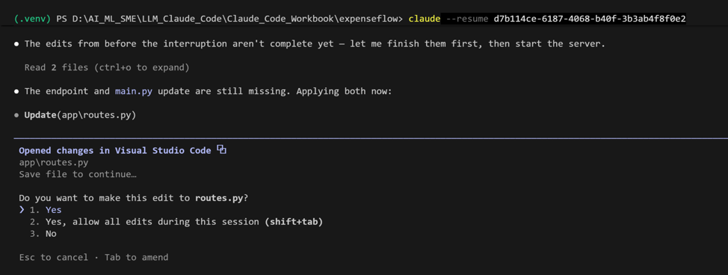

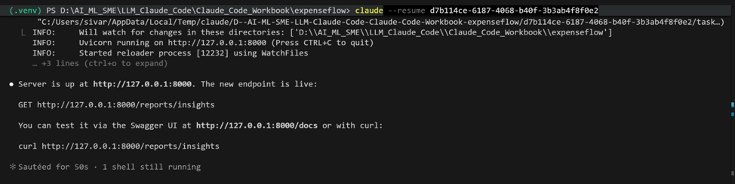
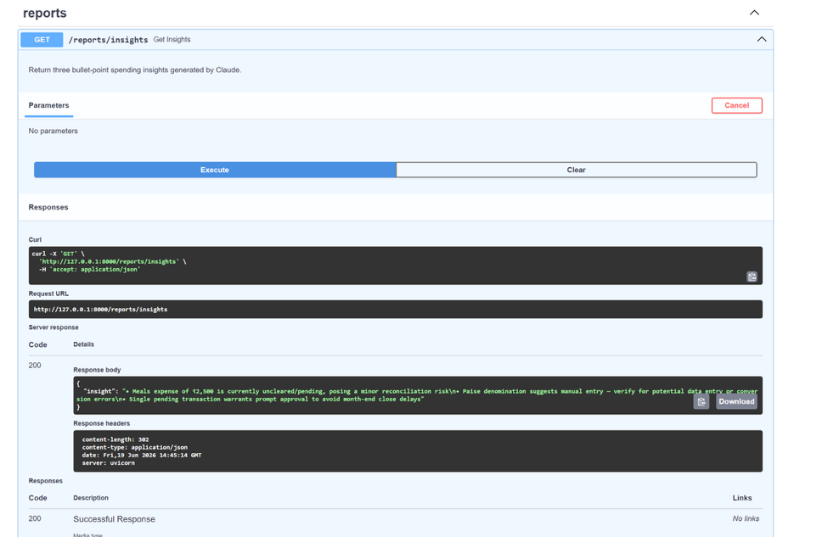

5 | Engineer the prompt for structured output
Free text is hard to render in a UI. Iterate the prompt so the model returns strict JSON, and make the code defensive about malformed output. This is prompt engineering as a development task, done through Claude Code.
Type this prompt into Claude Code
In app/insights.py, change the instruction so the model returns strict JSON only: an object with keys summary (a string) and bullets (an array of exactly three strings). Add a system prompt that says: respond with JSON only, no prose, no code fences. Parse the response with json.loads and validate the shape. If parsing fails, retry the call once, then fall back to a safe default object. Keep max_tokens small.
VALIDATE GET /reports/insights now returns structured JSON with summary and a three-item bullets array. Temporarily feed it a vague request and confirm malformed model output no longer crashes the route: it retries once, then returns the safe default.

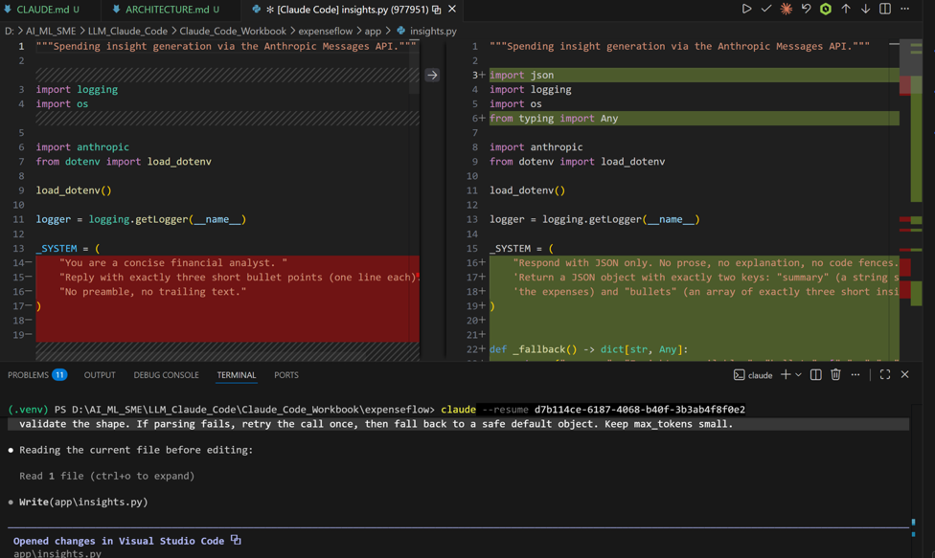

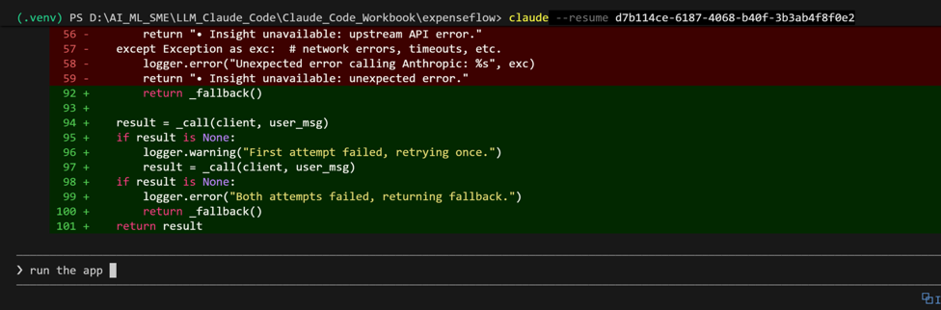
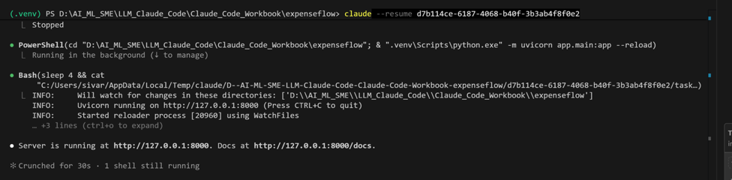
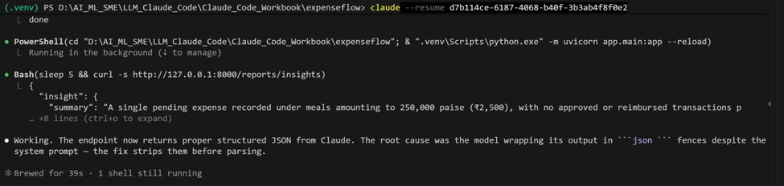
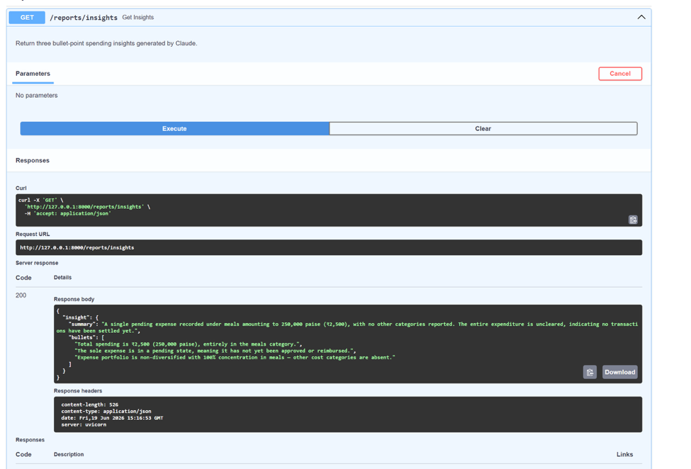

What success looks like
- You built a feature that calls the Claude API, entirely by directing Claude Code, and you can explain every line of app/insights.py.
- The API key lives only in .env, the call fails gracefully, and the endpoint returns predictable JSON.
- You can describe the difference between a system prompt and a user message, and why max_tokens and a fallback matter in production.
Common pitfalls (Windows and macOS)
- The key is read as empty: load_dotenv() must run before os.environ is read, and you must restart uvicorn after editing .env because --reload does not always re-read the environment.
- Committing .env. Confirm it is in .gitignore before your first commit in Exercise 12.
- A model-name typo (for example an old or misspelled name) raises a 404 from the API. The fallback hides it, so always read the uvicorn console when the insight looks wrong.
- Forgetting max_tokens leads to slower, costlier calls. Keep insight calls tight.
Stretch goal
Swap the model to claude-haiku-4-5 for a cheaper, faster call. Compare the insight quality against claude-sonnet-4-6 and check the difference with /cost inside Claude Code. Note which model you would pick for a latency-sensitive path.

